Demo of Configuring Package in SQL Server

In SSMS --

use master

go

create database SSIS_Package_Configuration

go

use SSIS_Package_Configuration

go

Create Table Emp_From_Text_File

(Empid Int,

EName varchar(30))

Go

In SSIS –

1. Create a folder SSIS_Pack_Config in C:
2. Create a new package with the name Pack_Config_Demo in the above folder.

3) Create a new package level variable called x of Int32 data type with default value 100 as shown next –

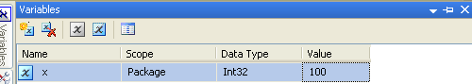

4) Place a Execute SQL Task in the Control Flow and change its name to **Deleting Existing Employees**.

Create a new connection to SSIS_Package_Configuration database and the SQL statement will be **Delete from Emp_From_Text_File** as shown next –

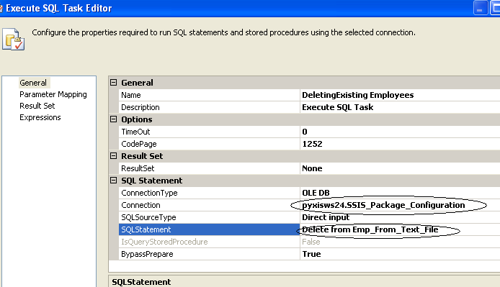

5) Create a text file with the following 4 records data:

1,a

2,b

3,c

4,d

Save this file as Emp_Text in the C:\SSIS_Pack_Config folder.

6) Right click in the Connection Managers (which is at the bottom side in Control Flow tab) and select Flat File Connection as shown next –

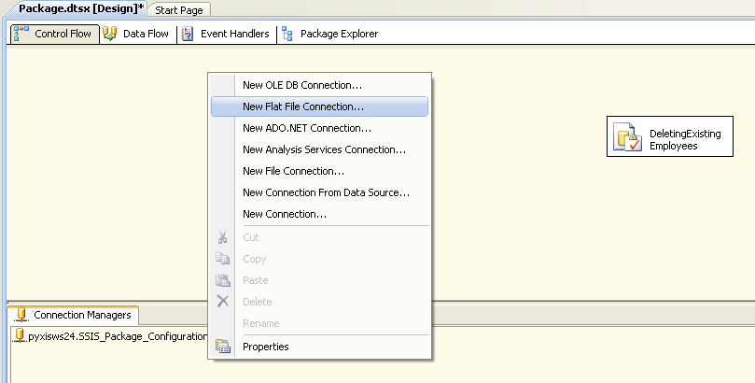

In the File name browse and select the Emp_text.txt file and select Columns, Preview and make sure all the 4 rows are visible.

In the Connection Manager one more icon gets added of Emp_Text as shown next –

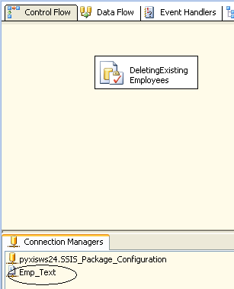

7) From the toolbox of Control Flow tab place a Data Flow control just below the Execute SQL Task and link it.

8) The Data Flow will have a text file as source and SS table as the destination.

a) Place a Flat File Source in the data flow.

b) Flat File Connection Manager will be Emp_text

c) Place an OLE DB Destination and map it with the Emp_From_Text_File table

The Data Flow tab should look like this:

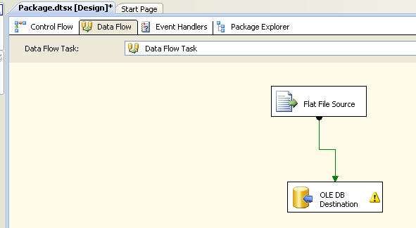

And the Control Flow tab will look this:

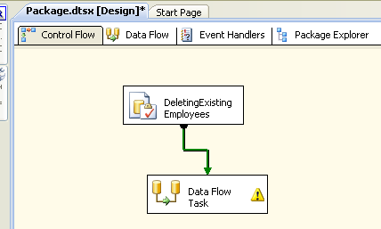

Let us run the package so that we will ensure whether things are right so far.

The green color for the package items should come indicating there are no errors.

In the SS table the 4 rows have been added.

So delete those rows.

In SSMS –

Delete from Emp_From_Text_File

In SSIS –

Now the package configurations will be saved in a new SS table.

For that right click any where in the Control Flow tab and select Package Configurations.. as shown next –

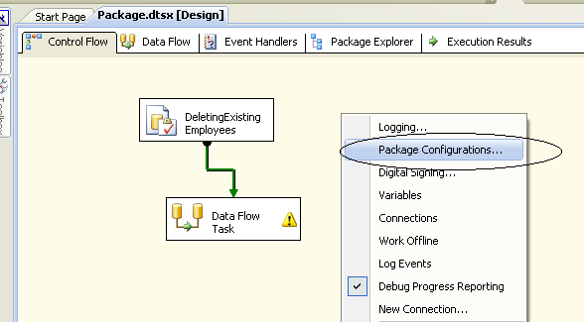

Select the Enable package configurations check box as shown next –

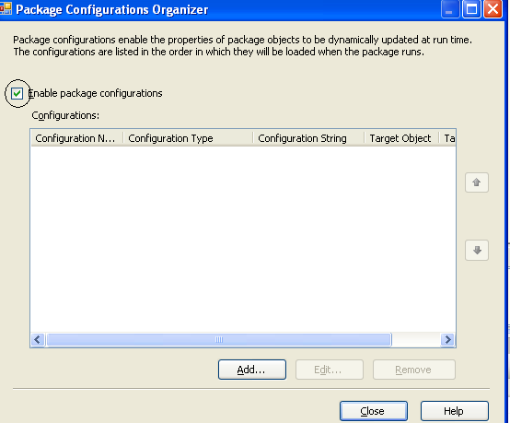

Click on the Add… button.

Package Configuration Wizard starts …

In the Configuration type select SQL Server.

Connection: ServerName.SSIS_Package_Configuration

Configuration table will be a new table.

Configuration Filter will be Employees_Filter as shown next –

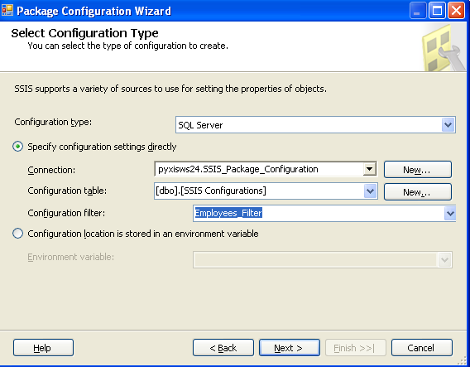

**Note 🡪 The Configuration Filter will be just an arbitrary string name given to all selected properties. All the selected properties are assigned to that filter. Because again if new configuration is done for the same project then the selected properties would be different. To identify each set of selected properties then configuration filter is must.**

Click on Next button.

In the step of Select properties to Export:

a) Select the following properties of the variable x:

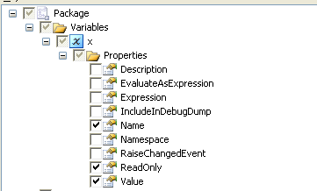

b) Select the following properties of the Emp_Text from the Connection Manager:

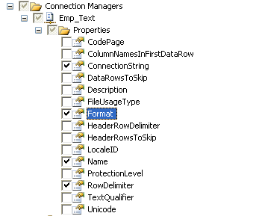

c) Select the following properties of the SSIS_Package_Configuration database

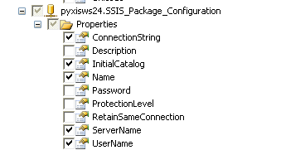

d) Select the Properties at package level as shown next –

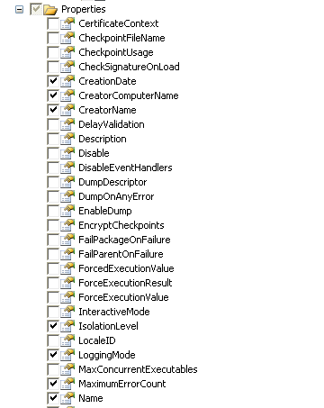

e) In the Executables select DeleteExisting Employees node and select SqlStatementSource property as shown next –

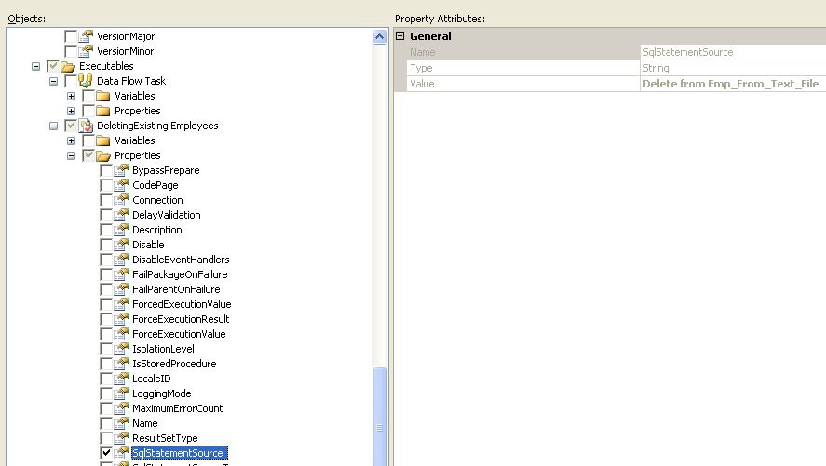

Click on the Next button.

Provide some meaningful name to the Configuration as My_Config. It shows you the selected properties in the pre view as shown next –

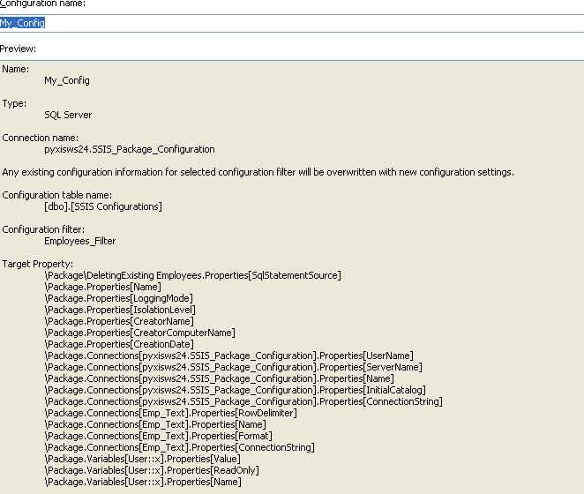

Then click on the Finish button and close the Package Configuration window.

Close the SSIS project.

Now in SSMS –

Under the Tables node a new table implicitly gets created with the name dbo.SSIS Configurations as shown next –

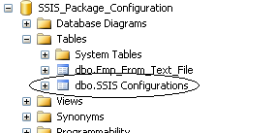

See the records of that table.

select * from [SSIS Configurations]

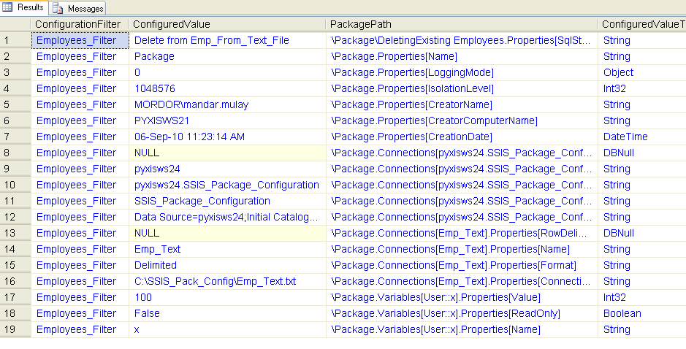

Case 1:

We can make changes in this table which will reflect in the existing SSIS package.

So let’s change the value of x variable from 100 to 500.

In SSMS -

**Update [SSIS Configurations]**

**set ConfiguredValue = '500'**

**where ConfiguredValue = '100'**

Open the SSIS project –

See the Variables window. The value of x is now 500!

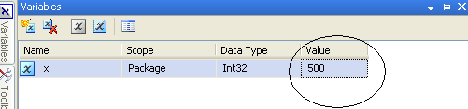

Close the project by saving the changes.

**Case 2:**

Now let’s change the SQL statement of the Execute SQL Task.

The new Delete statement will have a where clause.

Delete from Emp_From_Text_File where Empid <= 100

So come back in SSMS --

**Update [SSIS Configurations]**

**set ConfiguredValue = 'Delete from Emp_From_Text_File where Empid <= 100'**

**where PackagePath = '\Package\DeletingExisting Employees.Properties[SqlStatementSource]'**

Open the SSIS project again.

Open the Execute SQL Task Editor.

See the SQLStatement.

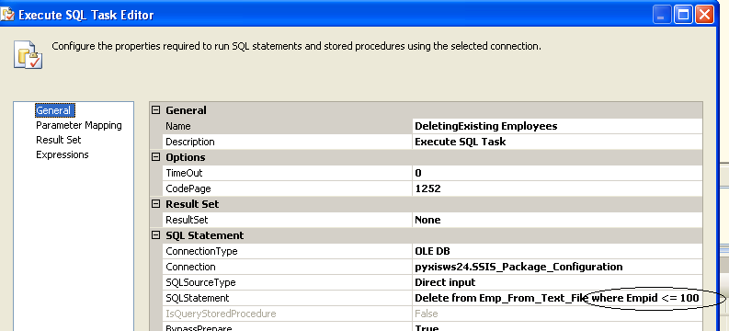

Close the project by saving the changes.

**Case 3:**

We will change the name of the text file inside the folder C:\SSIS_Pack_Config.

The existing name of the text file is Emp_Text.txt

Change that name to Emp_Text**_2010**.txt

If the package is run directly then it throws error.

So we will update the connection string’s value (i.e. path of the file)

In SSMS –

**Update [SSIS Configurations]**

**set ConfiguredValue = 'C:\SSIS_Pack_Config\Emp_Text_2010.txt'**

**where PackagePath = '\Package.Connections[Emp_Text].Properties[ConnectionString]'**

Open the SSIS project.

Open the window of Flat File Connection Manager Editor.

The name of the file has got changed as shown next –

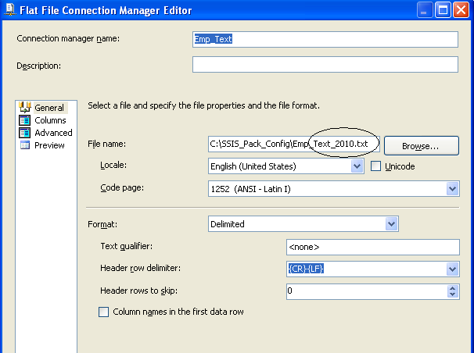

If the package is run now there is no error.